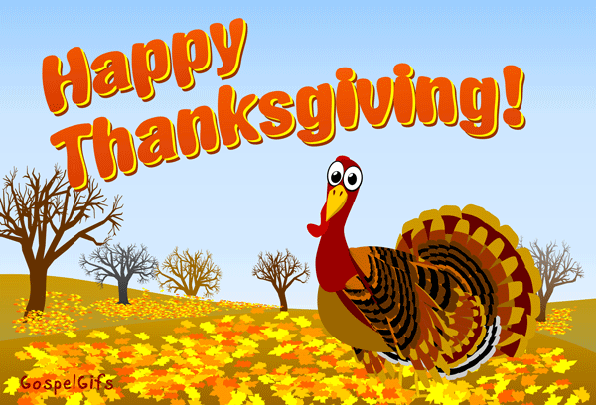
VILLAGE BOARD OF TRUSTEES
This Photo by Unknown Author is licensed under CC BY-NC-ND
NOVEMBER 21, 2022
MEETING @ 7:00 P.M.

MAYOR/BOARD
7:00 p.m. - Public Hearing/CDBG
- Notification of board meeting date change to December 5th (previously scheduled for December 19^{th)}
Approve 10/17/22 Minutes
- Approve 2023 Holiday Schedule
- Schedule Public Hearing for Local Law #1-2022/Building Code Updates
- Schedule Public Hearing for Local Law #2-2022/Tree Law
- ALS-BLS Joint Prehospital Service Agreement
- Request Executive Session to discuss Litigation

POLICE DEPARTMENT
Report

FIRE DEPARTMENT
- Report

RECREATION DEPARTMENT
Report
Request Executive Session to discuss Personnel

CODE ENFORCEMENT
- Report

HISTORIAN
Report

PUBLIC WORKS DEPARTMENT
Report

WATER & SEWER DEPARTMENT

ELECTRIC DEPARTMENT
Award Electric Hendrix Line Construction Materials Bid

TREASURER
Approval of Revenue & Expense Reports
- Request Executive Session

CLERK
Warrants

QUESTIONS FROM VISITORS

